INTRODUCTION TO
Computer Vision
Lecture 1 — Comprehensive Study Notes with Diagrams

Semester 2025–2026 | Prepared: April 2026
Software: Linux · Python · OpenCV

Table of Contents

1. What Is Computer Vision?
Imagine walking down a street. Without any conscious effort, your eyes and brain work together to recognize faces, read signs, judge distances, and avoid obstacles — all in real time. This seemingly effortless process is the result of billions of years of biological evolution. Computer Vision (CV) is the field of computer science that teaches machines to do exactly the same thing.

Definition
Computer Vision is the field of Artificial Intelligence that enables computers and machines to interpret, analyze, and extract meaningful information from visual data — such as images, videos, or camera streams — in a way that mimics or surpasses human visual perception.

The word 'visual data' is key. CV deals specifically with images and video — not text, not audio. The goal is always to understand what is in the picture or frame, and to produce useful information from it.

1.1 Why Is This Hard for Computers?
- An image is just a grid of numbers — millions of pixels, each with a color value. The computer sees no 'cat'; it sees arrays of integers.
- The same object looks different depending on lighting, angle, distance, occlusion, and scale.
- The visual world has enormous variety — every dog is slightly different, every face unique.
- Humans leverage context and world knowledge when interpreting scenes; classical software had none of this.

1.2 The Core Goal: Extracting Useful Information
Key Principle
The kind of information we want to extract is always application-specific. There is no single 'meaning' of an image — only the meaning relevant to your task.

Type of Information | Example
3D Models | Reconstructing a 3D shape of a building from 2D photos
Object Poses | Finding the exact position and orientation of a robotic arm's target
Object Categories | Classifying whether the image contains a dog, cat, or car
Camera Poses | Determining where the camera was when the photo was taken
Depth Information | Measuring how far away objects are
Motion Vectors | Tracking how objects move between video frames
Semantic Labels | Labeling every pixel as road, sky, building, etc.
Text in Images | Reading license plates, signs, handwriting (OCR)

2. Computer Vision's Place in the AI Landscape
To understand Computer Vision properly, you must understand where it sits within the broader world of Artificial Intelligence. The diagram below shows the relationship clearly.

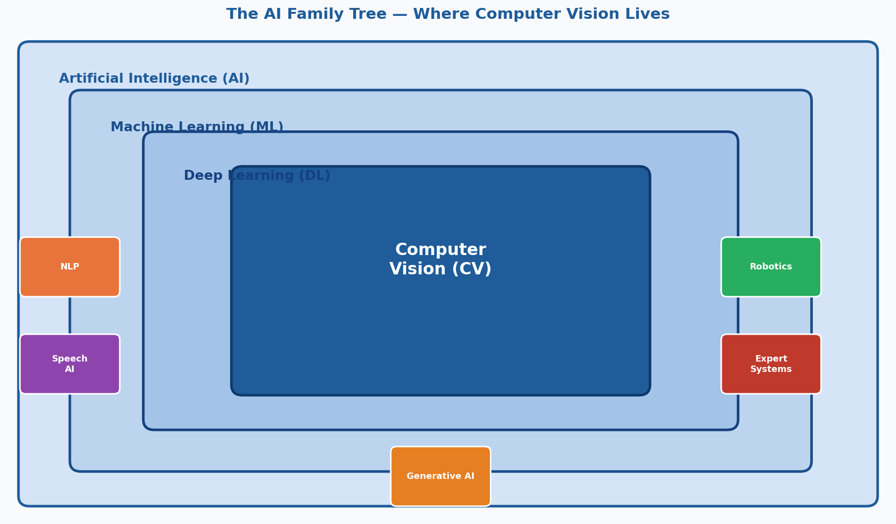
Figure 1: The AI Family Tree — Computer Vision sits inside ML and DL, alongside NLP, Robotics, and other domains.

2.1 The AI Sub-disciplines
AI Sub-discipline | What It Does
Machine Learning (ML) | Algorithms that learn from data and improve with experience, without being explicitly programmed for each task.
Deep Learning (DL) | A sub-field of ML using multi-layered artificial neural networks. DL is a subset of ML and the engine of modern CV.
Computer Vision (CV) | Enables machines to interpret and understand visual data (images, video). Often uses DL as its engine.
Natural Language Processing (NLP) | Enables machines to understand, generate, and translate human language — e.g., ChatGPT, Google Translate.
Speech Recognition / Audio AI | Converting spoken language to text; understanding audio signals.
Robotics AI | Combining perception (often CV), planning, and control to enable physical machines to act in the real world.
Reinforcement Learning (RL) | Training agents to make decisions by rewarding desired behaviors — used in game-playing AI and robotics.
Generative AI | AI that can create new content: images (DALL-E, Stable Diffusion), text (GPT), video (Sora).

3. The Vision System: Geometry, Physics & Learning Theory
Your lecturer described the pipeline as: Image → Vision System → Information. Inside that Vision System are three fundamental pillars. The diagram below illustrates the full pipeline.

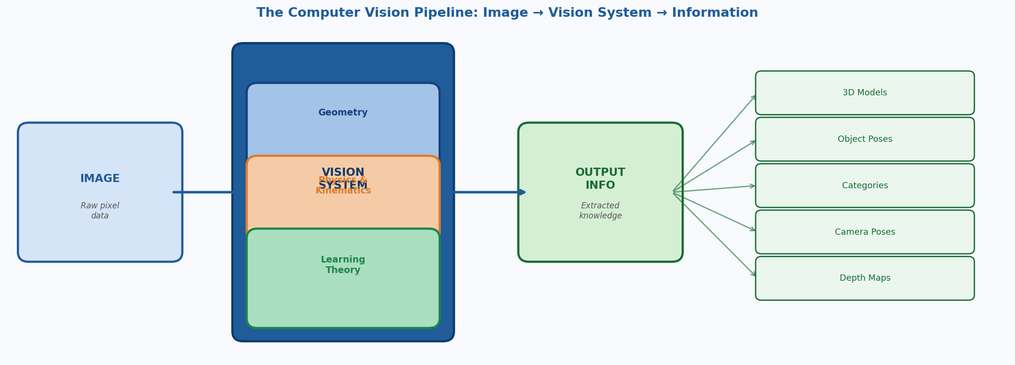
Figure 2: The CV Pipeline. An image enters the Vision System (comprising Geometry, Physics, and Learning Theory) and emerges as structured information.

3.1 Geometry
Geometry in CV deals with the mathematical relationships between the 3D world and 2D images. When a camera takes a photo, it 'projects' the 3D scene onto a 2D sensor. Geometry helps us understand and reverse this process.

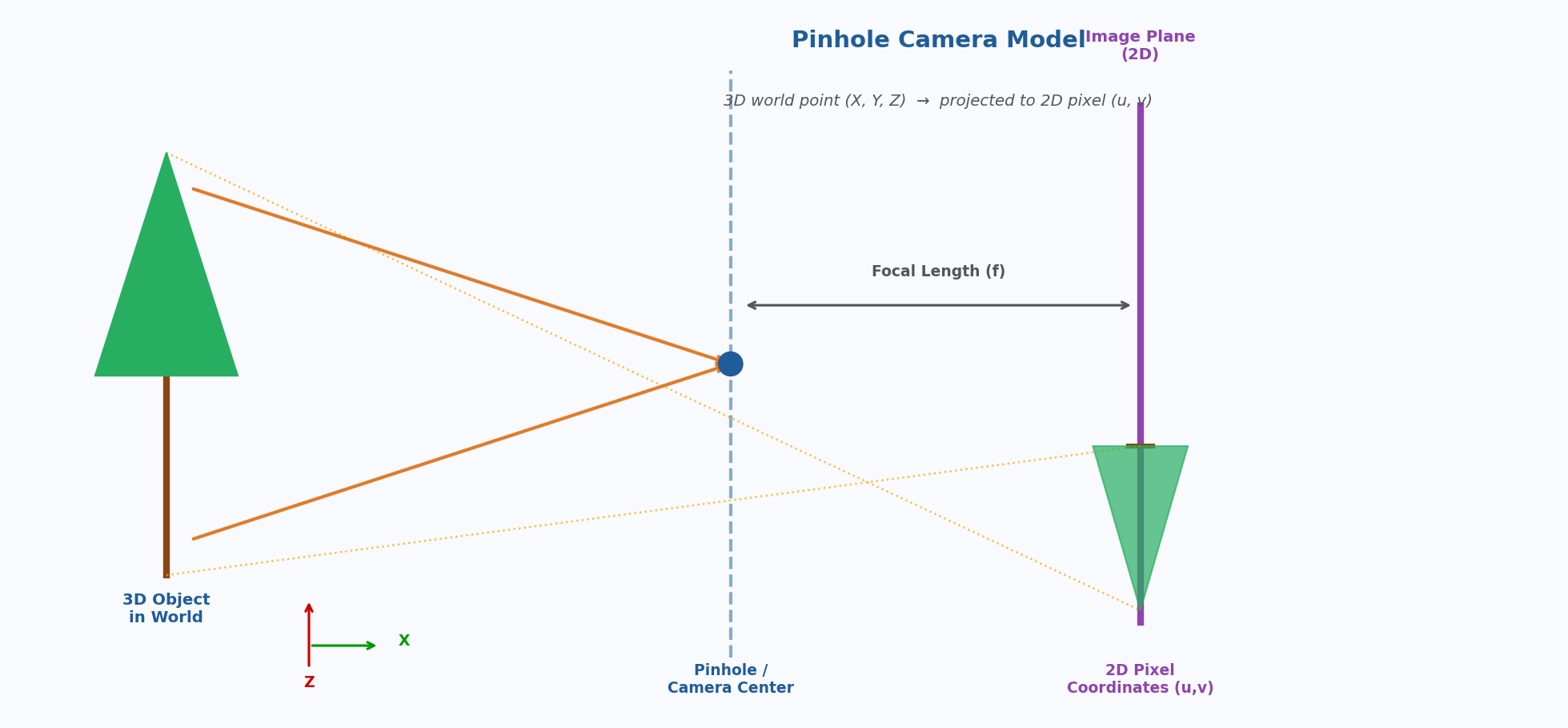
Figure 3: The Pinhole Camera Model — how a 3D scene is projected onto a 2D image plane. Focal length (f) determines how strongly the scene is magnified.

3.1.1 Camera Models
The simplest and most widely used model is the Pinhole Camera Model. The mathematics describe how a 3D point (X, Y, Z) in the world maps to a 2D pixel (u, v) in the image. Key parameters:
- Intrinsic parameters: focal length, principal point, and lens distortion.
- Extrinsic parameters: the camera's position and orientation in the world.

3.1.2 Epipolar Geometry
When you have two cameras (stereo vision) or two photos of the same scene from different angles, epipolar geometry describes the geometric relationship between the two views. This is fundamental for 3D reconstruction and stereo depth estimation.

3.1.3 Projective Transformations
Images can be related to each other by mathematical transformations — translations, rotations, scaling, perspective warps. Essential for image stitching (panoramas), augmented reality, and homography estimation.

3.2 Physics

3.2.1 Radiometry and Photometry
Radiometry studies the physics of light energy. In CV, we care about how much light a surface reflects (reflectance/albedo), the direction and intensity of light sources, and how surfaces appear differently under different lighting.

3.2.2 Kinematics
Kinematics describes motion without reference to forces — positions, velocities, and accelerations over time. In CV, this is critical for optical flow, object tracking, and predicting where a moving object will be in the next frame.

3.2.3 Color Science
Cameras capture light using R, G, B sensors (Bayer pattern). Understanding color models (RGB, HSV, LAB, grayscale) and their conversions is fundamental in any CV project using OpenCV.

3.3 Learning Theory
- Supervised Learning: Training on labeled examples (image + correct answer). Most common in CV.
- Unsupervised Learning: Finding patterns in unlabeled data.
- Self-supervised Learning: The model creates its own supervisory signal from the data. Powers modern large models like CLIP.
- Loss Functions: Mathematical measures of how wrong the model's predictions are.
- Gradient Descent and Backpropagation: The algorithms that optimize neural network weights by flowing error signals backward through the network.

4. The Receptive Field
Definition
The receptive field of a neuron in a neural network is the region of the input image that influences the output of that neuron. In other words: how much of the image does this neuron 'see'?

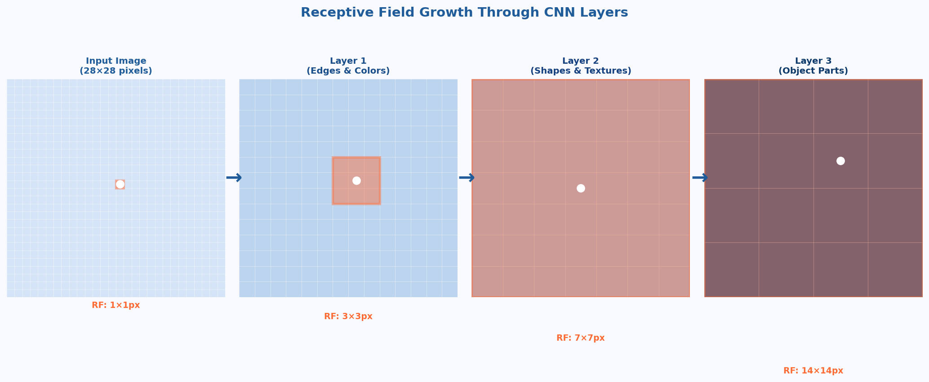
Figure 4: Receptive field growth through CNN layers. Orange highlighted region = what the center neuron 'sees'. Layer 1 sees 3×3px; by Layer 3 it sees 14×14px of the original image.

4.1 Biological Inspiration
In 1959, Hubel and Wiesel discovered that individual neurons in the visual cortex respond only to specific small regions of the visual field. The brain does not process the entire image all at once — many neurons each handle a small local region, and higher brain areas combine these into a global understanding. CNNs are directly inspired by this biological finding.

4.2 Receptive Fields in CNNs
- Early layers: Small receptive fields — neurons respond to edges, corners, and simple textures in a tiny patch (e.g., 3×3 pixels).
- Middle layers: Medium receptive fields — neurons respond to more complex patterns like eyes, wheels, or windows.
- Deep layers: Large receptive fields — neurons respond to entire objects, integrating information from many early neurons.

4.3 Why Receptive Field Size Matters
- Too small: Cannot capture context — cannot tell if an eye is part of a face.
- Too large: Wastes computation on irrelevant background and loses fine-grained detail.
- Dilated (atrous) convolutions allow the receptive field to grow rapidly without increasing computation.
- Vision Transformers (ViTs) have global receptive fields from the very first layer.

5. How CNNs Work — The Engine of Modern CV
Convolutional Neural Networks (CNNs) are the most important architecture in Computer Vision. Here is what the full architecture looks like:

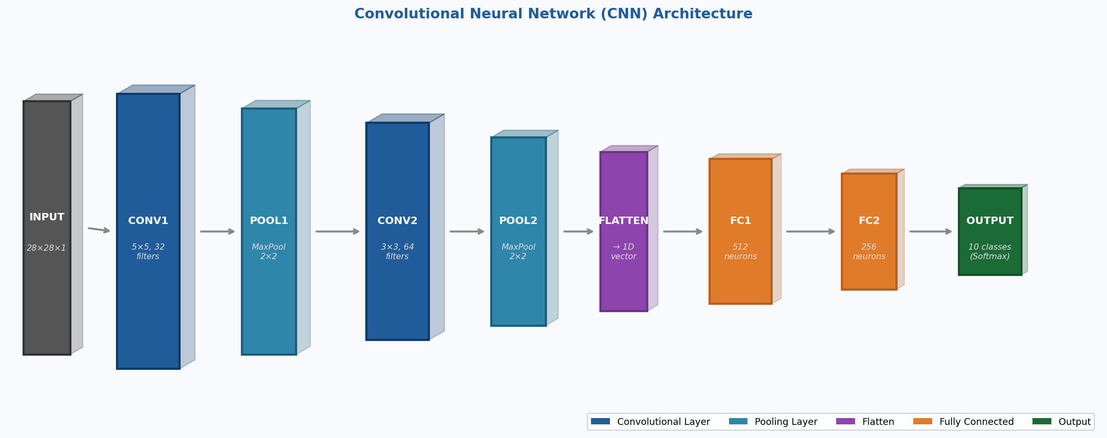
Figure 5: A typical CNN architecture. Input image → Convolutional layers (feature extraction) → Pooling layers (downsampling) → Fully Connected layers → Output classes.

5.1 Key Layers Explained
- Convolutional Layer (CONV): Slides small filters (kernels) over the image to detect local patterns. Each filter learns to detect a specific feature (edge, curve, texture).
- Pooling Layer (POOL): Reduces spatial dimensions (height, width) while keeping the most important features. Max Pooling takes the largest value in each region.
- Flatten: Converts the 3D feature maps into a 1D vector that can be fed to fully connected layers.
- Fully Connected Layer (FC): Traditional neural network layers that combine all features to make the final classification decision.
- Output (Softmax): Converts raw scores into probabilities for each class (e.g., 94% cat, 6% dog).

5.2 Types of Visual Recognition Tasks
Modern CV systems can be trained to perform very different kinds of visual understanding:

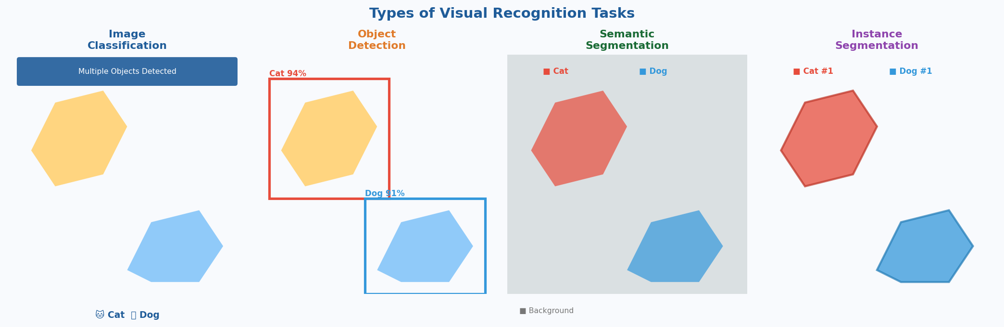
Figure 6: Four levels of visual recognition — Classification (label the whole image), Detection (locate with bounding boxes), Semantic Segmentation (label each pixel by category), Instance Segmentation (label each individual object separately).

6. Structure from Motion (SfM)
Structure from Motion answers the question: given a collection of 2D photos of a scene (taken from different angles), can we figure out the 3D structure of the scene and where the camera was for each photo?

Intuition
Imagine you walk around a building and take 100 photos from different positions. SfM can automatically stitch these into a 3D point cloud of the building — without any GPS, depth sensors, or manual measurement.

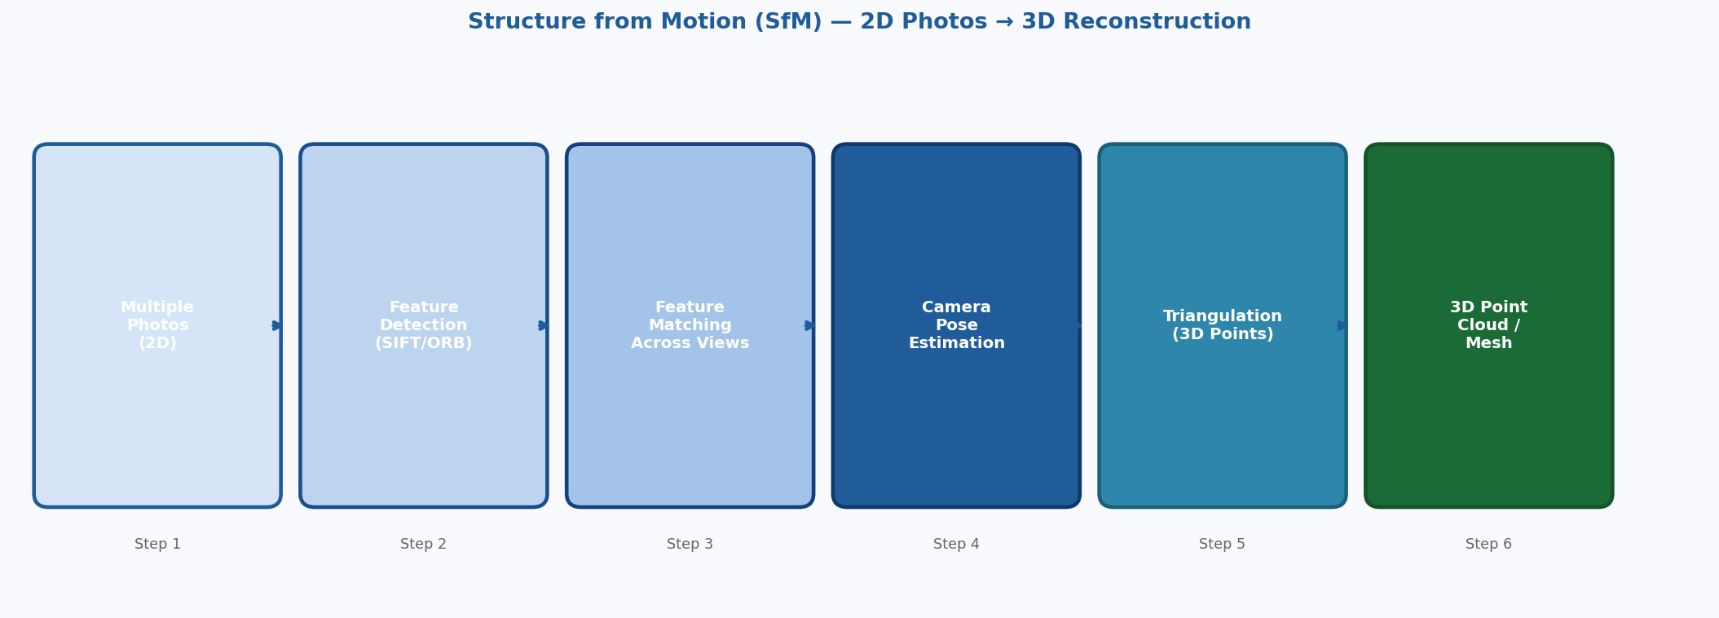
Figure 7: The Structure from Motion pipeline — from a collection of 2D photographs to a 3D point cloud or mesh.

6.1 How SfM Works
- Feature Detection: Find distinctive keypoints in each image (SIFT, ORB, AKAZE features).
- Feature Matching: Find the same physical point appearing in multiple images.
- Camera Pose Estimation: Use the matches to compute where the camera was for each photo.
- Triangulation: Given two cameras and a matched point, compute the 3D position of that point.
- Bundle Adjustment: Optimize all camera poses and 3D points simultaneously to minimize reprojection error.
- Dense Reconstruction: (Optional) Use Multi-View Stereo (MVS) to fill in a dense mesh.

6.2 Applications of SfM
- Google Street View 3D city models.
- Archaeological site documentation.
- Autonomous vehicle HD map creation.
- Film VFX — reconstructing real-world geometry for CGI integration.
- Drone-based surveying and precision mapping.

7. Face Detection
Face Detection locates all human faces in an image and draws bounding boxes around them. It is one of the oldest and most commercially deployed CV applications. Remember: Detection simply finds WHERE faces are. Recognition identifies WHOSE face it is.

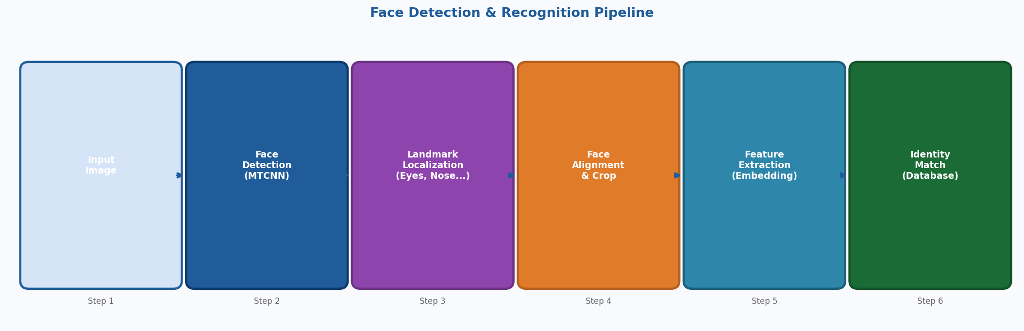
Figure 8: The complete face recognition pipeline — from raw image to identified person.

7.1 Classical Approach: Viola-Jones (2001)
- Haar-like features: Simple rectangular patterns computed extremely fast using integral images.
- AdaBoost: Selects the most discriminative features from thousands of candidates.
- Cascade classifier: A series of stages — simple checks first, complex later. Most regions fail the first stage instantly, making the algorithm very fast.
OpenCV still includes this detector (cv2.CascadeClassifier). It was the standard in consumer cameras for over a decade.

7.2 Modern Deep Learning Approach
- MTCNN (Multi-Task Cascaded CNNs): Simultaneously detects faces and facial landmarks (eyes, nose, mouth).
- RetinaFace: State-of-the-art single-stage face detector with landmark detection.
- YOLO-based detectors: Adapted for face detection with very high speed.

8. Applications of Computer Vision
Computer Vision is one of the most impactful AI technologies — it touches virtually every industry. The diagram below gives an overview of the major application domains.

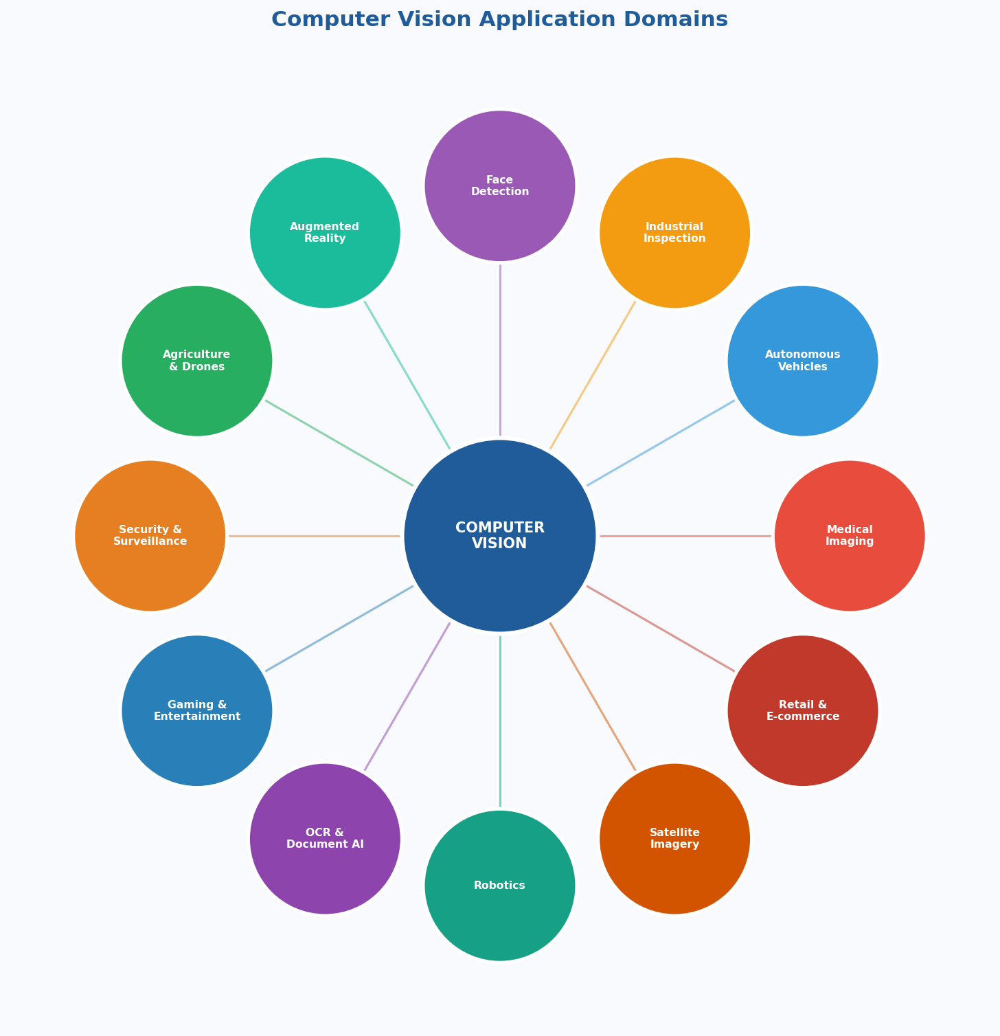
Figure 9: Computer Vision application domains across industries — from medical imaging to autonomous vehicles, gaming, agriculture, and more.

8.1 Optical Character Recognition (OCR)
One of the earliest and most commercially successful CV applications. Converts images of text (scanned documents, photos of signs, handwriting) into machine-readable text. Applications: document digitization, license plate reading, postal sorting.

8.2 Industrial Inspection and Quality Control
- Detecting defects in circuit boards (missing components, solder bridges).
- Checking pill counts and foreign objects in pharmaceutical production.
- Inspecting welds in automotive manufacturing.
- Grading fruit and vegetables by size, color, and defect level.

8.3 Mobile Robot Control and Autonomous Navigation
- Lane detection and road segmentation for self-driving cars.
- Obstacle detection and avoidance.
- Visual SLAM for indoor robots.
- Sign and traffic light recognition.

8.4 Military and Defense Intelligence
- Satellite image analysis — detecting military activity, monitoring infrastructure changes.
- Drone surveillance and target identification.
- Automated threat detection in real-time security feeds.
Note: These applications raise serious ethical questions around autonomous weapons and surveillance that the field actively debates.

8.5 Medical Imaging
- Radiology: Detecting tumors in X-rays, CT scans, and MRIs.
- Pathology: Analyzing tissue samples under microscope for cancer.
- Ophthalmology: Detecting diabetic retinopathy from retinal photos.
- Dermatology: Classifying skin lesions as benign or malignant from smartphone photos.

8.6 Gaming and Entertainment
- 3D Game Development: Photogrammetry captures real-world objects and converts them to game assets.
- Motion Capture: Tracking actors to animate 3D characters.
- Virtual Reality (VR) and Mixed Reality (MR): Inside-out tracking, hand tracking.
- Deepfakes and VFX: Face swapping and de-aging in film.

8.7 Other Key Domains
- Agriculture: Crop disease detection from drone imagery, precision irrigation.
- Retail: Amazon Go cashierless stores, visual search, inventory management.
- Security: CCTV analysis, crowd monitoring, anomaly detection.
- Augmented Reality: Snapchat/Instagram filters, Apple Vision Pro, HoloLens.
- Environment: Monitoring deforestation from satellite images, wildlife counting.

9. Tools and Software

9.1 Linux
Linux (typically Ubuntu) is the standard operating system for CV and AI development. GPU drivers, CUDA, and deep learning frameworks work most reliably on Linux. All AI cloud servers run Linux — develop locally in the same environment you'll deploy to.

9.2 Python
Python is the dominant language for CV and AI. Rich ecosystem: NumPy (images as arrays), OpenCV (cv2), Pillow (image I/O), Matplotlib (visualization). Deep learning frameworks: PyTorch (research) and TensorFlow/Keras (production).

9.3 OpenCV
The world's most widely used CV library — over 2,500 optimized algorithms, available in Python (cv2), C++, and Java.
OpenCV Module | What It Does
Image I/O | cv2.imread(), cv2.imwrite(), cv2.VideoCapture() — load and save images and video
Image Processing | Filtering (Gaussian blur, bilateral filter), morphological operations, thresholding
Edge Detection | Canny, Sobel, Laplacian edge detectors
Feature Detection | SIFT, ORB, AKAZE keypoint detection and matching
Camera Calibration | Computing intrinsic and extrinsic camera parameters
Stereo Vision | Disparity map computation, 3D reconstruction
Object Detection | Pre-trained Haar cascades, DNN module for deep learning models
Optical Flow | Lucas-Kanade, Farneback dense optical flow
Video Analysis | Background subtraction, object tracking (KCF, CSRT, MIL)
DNN Module | Run pre-trained models from PyTorch, TensorFlow, ONNX in OpenCV

10. Glossary — Key Concepts
Term | Definition
Pixel | Smallest unit of a digital image; stores color values (R, G, B, each 0–255).
Feature | A distinctive property of an image region — edge, corner, blob, or learned CNN activation.
Bounding Box | A rectangle (x, y, width, height) used to locate an object in an image.
Segmentation Mask | Pixel-level map where each pixel is labeled with its object or class.
Depth Map | Image where each pixel's value = distance to the camera, not color.
Point Cloud | Set of 3D points (X, Y, Z) representing a scene in 3D space.
Homography | 3×3 matrix describing projective transformation between two image planes.
Calibration | Finding a camera's intrinsic parameters (focal length, lens distortion, etc.).
Pose (6-DOF) | Position (X, Y, Z) + orientation (roll, pitch, yaw) of an object or camera.
Disparity | Stereo vision: pixel position difference of the same point between left/right cameras. Inversely proportional to depth.
Optical Flow | Apparent motion of pixels between consecutive video frames.
Receptive Field | Area of input image influencing a particular neuron's output in a CNN.
Convolution | Math operation sliding a small filter over an image to detect local patterns.
SLAM | Simultaneous Localization and Mapping — robot builds a map while tracking its own position.
IoU | Intersection over Union — key metric for object detection accuracy.
Backpropagation | Algorithm that flows error signals backward through a neural network to update weights.
Transfer Learning | Using a pre-trained model on a new task, saving massive training time and data.

11. Complete Computer Vision Roadmap (April 2026)
This section provides the full landscape of the field — its capabilities, limitations, future, and how to build a career or project in it.

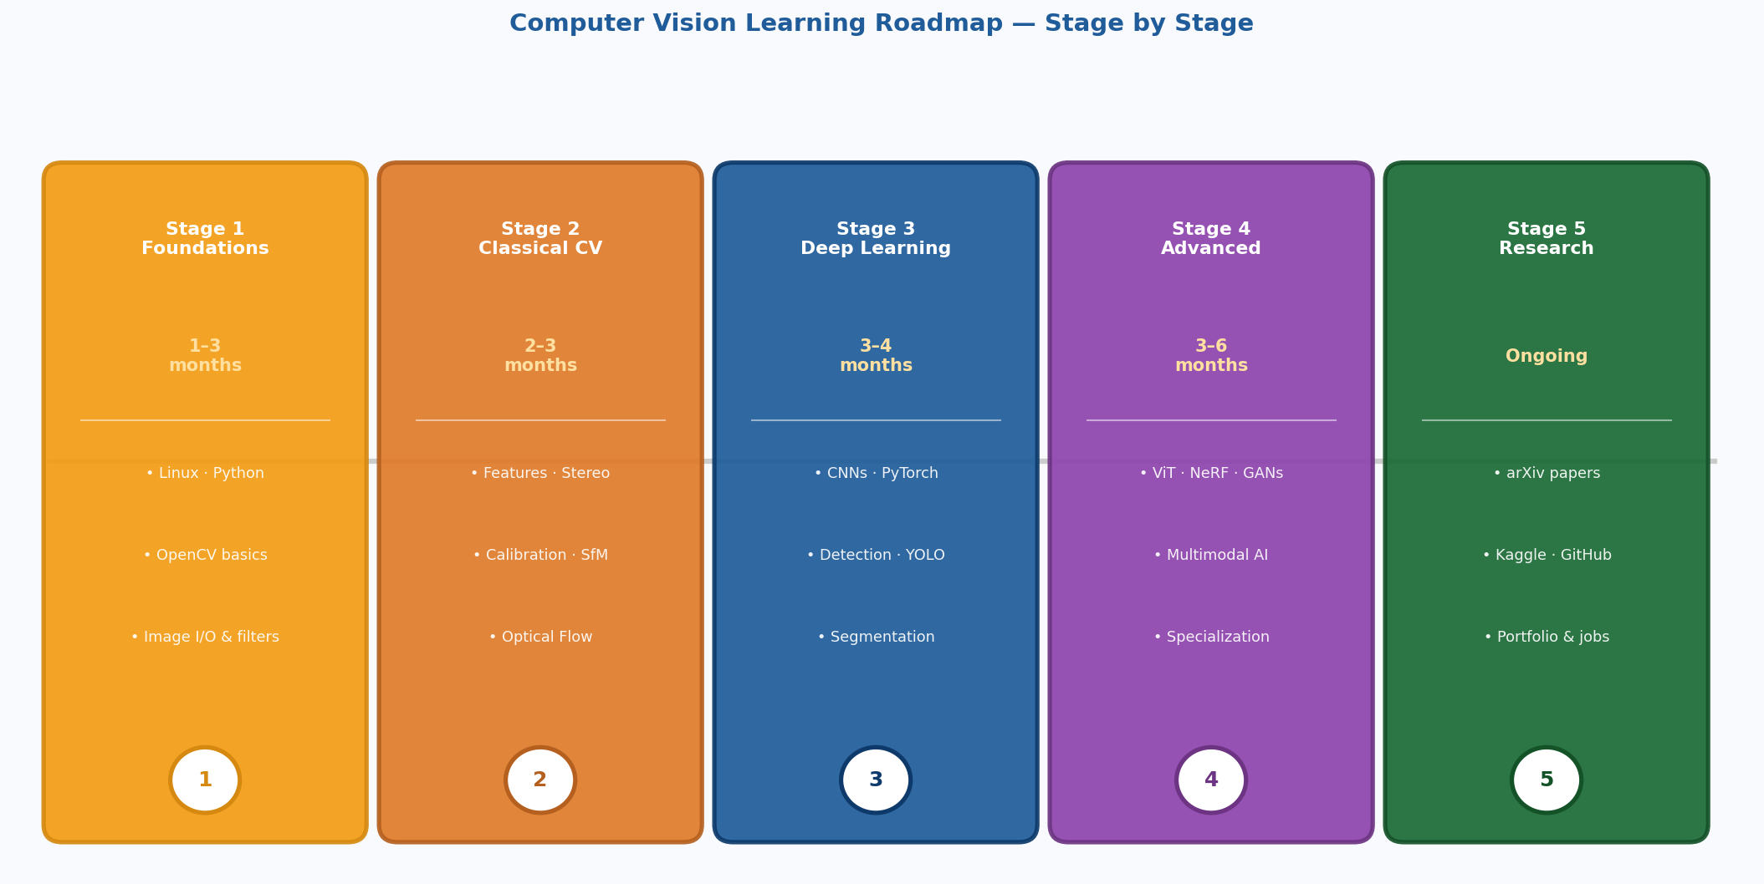
Figure 10: The 5-stage Computer Vision learning roadmap — from foundations to research-level mastery.

11.1 Prerequisites Before Starting

Mathematics
- Linear Algebra: Vectors, matrices, matrix multiplication, eigenvectors, SVD. Images are matrices; neural networks are matrix operations.
- Calculus: Derivatives, partial derivatives, chain rule (needed for backpropagation).
- Probability & Statistics: Probability distributions, Bayes' theorem, mean/variance.
- Optimization: Gradient descent and its variants (Adam, SGD, RMSprop).
- Geometry: Coordinate systems, transformations, vectors in 3D space.

Programming
- Python proficiency: Variables, functions, classes, file I/O, debugging.
- NumPy: Array operations, broadcasting, slicing — images are NumPy arrays.
- Git and GitHub: Version control for your code.
- Linux command line basics: Navigation, file management, running scripts.

Core ML Concepts
- Supervised vs. unsupervised learning.
- Train/validation/test splits and why they exist.
- Overfitting and regularization techniques.
- Evaluation metrics: accuracy, precision, recall, F1-score, IoU.

11.2 Stage-by-Stage Learning Path
Stage 1: Foundations (1–3 months)
Install Linux, Python, OpenCV. Learn to read/display/manipulate images. Understand color spaces (BGR, RGB, HSV, grayscale). Practice: filtering, Canny edges, thresholding, contours. Mini-project: color-based object tracker.

Stage 2: Classical CV (2–3 months)
Feature detection (SIFT, ORB), feature matching, image stitching. Camera calibration with chessboard patterns. Stereo vision and depth maps. Optical flow (Lucas-Kanade). Structure from Motion intro (COLMAP). Mini-project: real-time face detector with Haar cascades.

Stage 3: Deep Learning for Vision (3–4 months)
Learn PyTorch fundamentals. Understand CNNs: convolutions, pooling, batch norm. Key architectures: LeNet → AlexNet → VGG → ResNet → EfficientNet. Train image classifiers on CIFAR-10 (transfer learning). Object detection: YOLO, Faster R-CNN. Segmentation: U-Net, DeepLab. Mini-project: custom object detector with YOLOv8.

Stage 4: Advanced Topics (3–6 months)
Vision Transformers (ViT, DINO, SAM). Generative models: GANs, Diffusion Models, NeRF, 3D Gaussian Splatting. Video understanding: action recognition. Multimodal AI: CLIP, GPT-4V, LLaVA. Choose a specialization.

Stage 5: Research / Industry (Ongoing)
Read arXiv (cs.CV) — 2–3 papers/week. Reproduce landmark papers in PyTorch. Contribute to open-source CV projects. Build a portfolio of 3–5 strong GitHub projects. Participate in Kaggle CV competitions.

11.3 Current State of CV (April 2026)

What CV Does Incredibly Well
- Image classification: Near-human or superhuman accuracy on ImageNet.
- Face recognition: Extremely accurate under controlled conditions.
- Object detection: Real-time detection of 100s of categories at high accuracy.
- Medical image analysis: Matching radiologist accuracy in specific tasks.
- Image generation: Photorealistic images from text (Stable Diffusion 3, DALL-E 3).
- Video generation: High-quality video clips from text prompts (Sora, Runway Gen-3).
- 3D reconstruction: High-quality NeRF and 3D Gaussian Splatting models from smartphone video.
- Autonomous driving: Level 2–3 autonomy at scale; Level 4 in limited geofenced areas (Waymo).

Current Limitations
- Long-tail robustness: Systems fail on rare scenarios not in training data — a major problem for autonomous vehicles.
- Data hunger: Most deep learning models require enormous labeled datasets.
- Adversarial vulnerability: Small, imperceptible perturbations can fool CV models.
- Reasoning and common sense: CV excels at pattern recognition but struggles with causal reasoning.
- Computational cost: State-of-the-art models require powerful GPUs — challenging for edge deployment.
- Bias and fairness: CV models can exhibit racial, gender, or socioeconomic bias.
- Interpretability: We often cannot explain why a neural network made a particular decision.

11.4 Future Directions
- Foundation Models for Vision: Large pre-trained models (SAM 2, DINOv2) fine-tunable for any task.
- World Models: AI systems that build internal 3D models of the world from video.
- Embodied AI: Combining CV with robotics and language so robots can see, understand, and act.
- Neuromorphic Vision: Event-based cameras — extremely low power and high speed.
- 4D Reconstruction: Reconstructing dynamic scenes in full 3D over time.
- Efficient Vision (TinyML): Tiny models running on microcontrollers for IoT.
- Medical AI Integration: FDA-approved CV diagnostic tools becoming standard clinical practice.
- Synthetic Data Revolution: Using generative AI to create unlimited labeled training data.

11.5 Final Year Project Ideas

Beginner-Friendly
- Real-time sign language recognition: Hand gesture detection + custom classifier using MediaPipe.
- Attendance system using face recognition: MTCNN + FaceNet to identify students from a camera feed.
- Traffic density monitoring: Count vehicles using YOLOv8 and estimate congestion levels.
- Plant disease detection: CNN classifier for crop diseases from leaf images.

Intermediate
- Autonomous navigation robot: Camera + SLAM to navigate an indoor environment.
- 3D room reconstruction: Smartphone + NeRF/3DGS to create a 3D room model.
- Surgical instrument tracking: Detect and track instruments in laparoscopic video.
- Defect detection system: Industrial CV for quality control on a simulated production line.

Advanced / Research-Level
- Multimodal visual question answering: CLIP or LLaVA-style architecture.
- Video action recognition with temporal transformers: Video Swin Transformers.
- Novel view synthesis: NeRF-based rendering from 10 input photos.
- Federated learning for medical imaging: Train without sharing patient data.

11.6 Career Paths in Computer Vision
Role | What You Do
Computer Vision Engineer | Implement, optimize, and deploy CV models in products. Requires strong Python, C++, PyTorch skills.
ML Engineer (CV Focus) | Build pipelines, training infrastructure, and serving systems for CV models at scale.
CV Research Scientist | Invent new algorithms. Requires PhD-level mathematical depth and publication record.
Robotics Engineer | Combine CV with control systems for autonomous robots.
AI Product Manager | Define the product roadmap for CV-powered products.

Top Companies Hiring CV Engineers (2026)
- Technology Giants: Google DeepMind, Meta AI, Apple, Microsoft, Amazon, NVIDIA.
- Autonomous Vehicles: Waymo, Tesla, Mobileye, Zoox.
- Medical AI: Tempus, PathAI, Viz.ai, Aidoc.
- Industrial Automation: Cognex, Keyence, Landing AI.

11.7 Pursuing a Master's or PhD

Strong Programs Worldwide
- Carnegie Mellon University (CMU) — Robotics Institute, globally top-ranked.
- Stanford University — Computer Vision group (created ImageNet).
- ETH Zurich — World-leading CV and Robotics research.
- University of Toronto — Vector Institute (Hinton's group, deep learning birthplace).
- Oxford / Cambridge — VGG group (VGGNet creators).
- NUST / FAST (Pakistan) — Strong local programs with growing research output.

Key Academic Venues to Know
- CVPR — Computer Vision and Pattern Recognition (most prestigious CV conference).
- ICCV — International Conference on Computer Vision.
- ECCV — European Conference on Computer Vision.
- NeurIPS / ICLR — Top ML conferences where CV papers appear.

11.8 Best Resources for Self-Study

Textbooks
- Computer Vision: Algorithms and Applications — Richard Szeliski (free online, comprehensive).
- Deep Learning — Goodfellow, Bengio, Courville (deep learning bible, free online).
- Multiple View Geometry in Computer Vision — Hartley & Zisserman (essential for 3D CV).

Online Courses
- Stanford CS231n: Deep Learning for Computer Vision — The gold standard online CV course.
- fast.ai Practical Deep Learning for Coders — Hands-on, top-down approach.
- Coursera: Deep Learning Specialization (Andrew Ng) — Solid ML/DL foundation.

Practice Platforms
- Kaggle — CV competitions with real datasets.
- Papers With Code — Track state-of-the-art results and find code for landmark papers.
- Roboflow Universe — Thousands of labeled CV datasets for practice.
- Hugging Face — Pre-trained vision models ready to use.

Summary — Key Takeaways
What Is Computer Vision?
CV is the AI discipline that extracts meaningful information from visual data (images/video). It is a subset of AI that works closely with Machine Learning and Deep Learning.

The Three Pillars
Every vision system rests on Geometry (how images project 3D worlds), Physics (how light creates images — including kinematics for motion), and Learning Theory (how machines learn from data).

Application-Specific Output
What information a CV system extracts depends entirely on the application: 3D models, object poses, object categories, camera poses, depth maps, segmentation masks — and more.

The Receptive Field
In a CNN, each neuron only 'sees' a limited region of the input image. This grows with network depth, enabling simple local feature detection to build up to complex object recognition — mirroring how the human visual cortex works.

Key Software Stack
Linux (Ubuntu) + Python + OpenCV is the standard entry-point toolkit. Deep learning work additionally uses PyTorch or TensorFlow.

CV Does NOT Cover
Text, audio, and non-visual sensor data are NOT Computer Vision. CV only processes pixel grids — images and video.

Good luck in your next class! Computer Vision is one of the most exciting and impactful fields you can study. The journey from reading pixels to building systems that see and understand the world is deeply rewarding.

